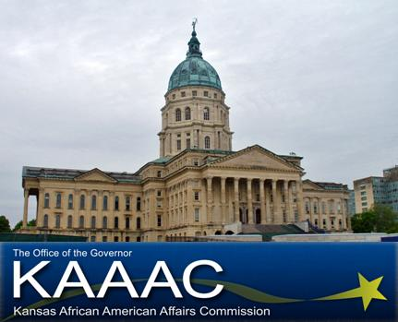 | African American Youth Day: Quest for the Best!  Topeka, Kansas  March 22, 2011  Completed applications due by March 11  Helpful Facts & Schedule of Events

Helpful Facts

Who can participate in African American Youth Day?
Young people ages 9-20 throughout the State of Kansas who want to discover their leadership skills.

What will happen at the Event?
We will....
- Bring together young people to share information with each other. Topics such as leadership, goal setting, assertiveness, disability awareness, advocacy, cultural heritage, and much more.
- Involve numerous presenters, such as community leaders, legislators and other professionals who will interact with the students.
- Identify existing barriers to personal and professional success and develop plans to deal effectively with those barriers.
- Assist in developing a “Personal Leadership Plan” which will include specific action plans for the students when they return to their communities.
- Participate in activities such as: small group discussions with fellow students, large group presentations by successful community leaders, a luncheon with community mentors, and a picture at the State Capitol.

What is involved in the application process?
Student applicants must mail the completed application packet to the KAAAC office no later than March 11. Selected applicants will be notified by letter, with detailed information regarding the Forum. Approximately 30-40 youth will be accepted to attend.

Cost:
Except for $5 for the cost of the lunch, there will be NO charge for student delegates or volunteers to participate in this leadership event. All appropriate expenses will be paid by KAAAC including interpreters for deaf students, personal care attendants, and other accommodations, as needed.

Transportation:
Parents or guardians must provide transportation for their students to and from events.

Schedule of Events

Legislative Pages:
Pages, ages 9-12, will be connected with their area State legislature and shadow them for the day. This will give them an in depth view into the political process and how they can become engaged at a young age.

Tentative Page schedule:

7: 00 am – Arrive at Kansas African American Affairs Commission
- Doughnut and juice provided
- Introduction and Orientation Break-out Session

8:00 am – Report to Capitol building
- Meet representative
- Begin shadowing process

12:00 – 1:50 – Lunch and Awards Ceremony

2: 00pm Capitol Tour

3: 00 Brown v. Board Museum

Junior Delegates:
Junior delegates, ages 13 – 16, will host a community service project in collaboration with State Legislatures and the Corporation for National and Community Service. This will give them an in depth view into the importance of civic engagement and how they can give back to the community.

Tentative Junior Delegate schedule:

7: 00 am – Arrive at Kansas African American Affairs Commission.
- Doughnut and juice provided
- Introduction and Orientation Break-out Session

8: 00 am – 11: 30 – Community Service Project

12:00 – 1:50 – Lunch and Awards Ceremony

2: 00pm Capitol Tour

3: 00 Brown v. Board Museum

Senior Delegates:
Senior delegates, ages 17-20, will create a strategic plan of African American youth involvement pertaining to issues they feel effect their communities. They will then present this plan to the Kansas African American Affairs Commission and brainstorm ideas of implementation. The senior delegate with the strongest application will be offered an internship with the Kansas African American Affairs Commission.

Tentative Senior Delegate schedule:

7: 00 am – Arrive at Kansas African American Affairs Commission.
- Doughnut and juice provided
- Introduction and Orientation Break-out Session

8:00 am – Develop strategic plan: African American Youth Leadership: The next 150 years

10:00 am – Present plan and implementation to KAAAC Commission

11:00 am – Capitol Tour

12:00 – 1:50 – Lunch and Awards Ceremony

2:00 Brown V. Board Museum

For additional information, please contact the KAAAC office
at 785.296.4874 or email: shawn.bryant@ks.gov
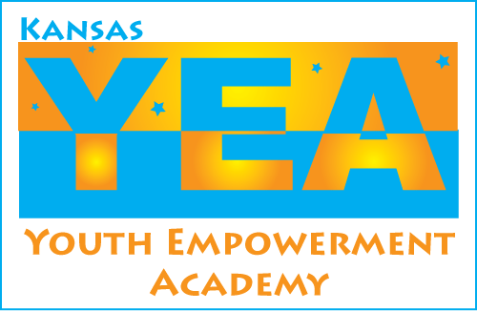
Fact sheet format used with permission on the Kansas Youth Empowerment Academy

